[insert organization logo]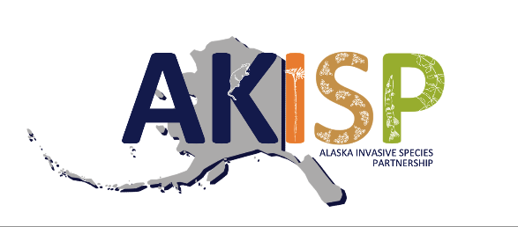

For release on [date].

Celebrate Alaska Invasive Species Awareness Week
Share information and participate in local events June 8-14
[Your organization name] invites all Alaskans and Alaska visitors to join us in celebrating Alaska Invasive Species Awareness Week on June 8 -14, 2025. This week is designated by an Executive Proclamation issued by Governor Dunleavy and celebrates the work being done by partners to manage invasive species in Alaska. [include information about local events as appropriate]
An invasive species is any living thing that is not native to a particular place of interest and when introduced to that place causes harm to the environment, economy, and/or human health. Despite its perceived remoteness, Alaska is confronted by a growing number of terrestrial and aquatic invasive species. Whether assisted by humans or not, invasive species are constantly on the move. To stay informed of spread and new introductions, coordinated survey efforts are necessary to detect and address new threats. Early detection and rapid response are critical tools for preventing the spread of invasive species in Alaska, helping to mitigate their negative impacts.
[can add/adjust information to include local invasive species of concern]
During Alaska Invasive Species Awareness week, the AKISP will be promoting popular nationwide educational campaigns, including: “Stop Aquatic Hitchhikers! Clean Drain Dry”, “PlayCleanGo”, “Buy It Where You Burn It”, and “Don’t Let It Loose”. These messages are relevant to both Alaskans and visitors to the state.
In addition to these awareness campaigns, the AKISP will be highlighting invasive species reporting tools. Anybody in Alaska can report an invasive species by calling 1-877-INVASIV (468-2748) or by using the Alaska Department of Fish and Game Online Reporter. There are a number of invasive species identification and reporting apps available as well, including the Alaska Invasives ID app. [include information about local contacts as needed]
[additional information about relevant events and activities and where to find this information]
You can find more information by following the AKISP Facebook Page, by signing up for the AKISP listserv, or by visiting the AKISP website. You can continue to stay engaged with invasive species topics by attending the statewide Alaska Invasive Species Workshop in Anchorage, October 28-30, 2025.
[information on your organization]
The Alaska Invasive Species Partnership is an informal group of individuals representing agencies and organizations statewide. Anyone may participate. The goal of the AKISP is to heighten awareness of the problems associated with non-native invasive species and to bring about greater statewide coordination, cooperation, and action to halt the introduction and spread of invasive species.

Contacts for this press release:
Name, affiliation
- Email:
- Cell:

Images:








