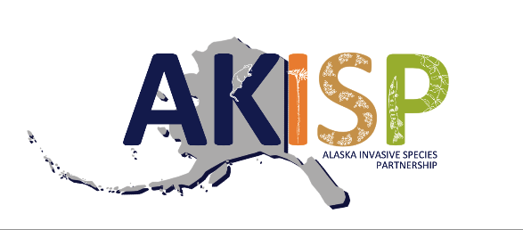

For release on June 2, 2025:

Celebrate Alaska Invasive Species Awareness Week
The Alaska Invasive Species Partnership (AKISP) invites all Alaskans and Alaska visitors to join us in celebrating Alaska Invasive Species Awareness Week on June 8 -14, 2025. This week is designated by an Executive Proclamation issued by Governor Dunleavy and celebrates the work being done by partners to manage invasive species in Alaska.
An invasive species is any living thing that is not native to a particular place of interest and when introduced to that place causes harm to the environment, economy, and/or human health. Despite its perceived remoteness, Alaska is confronted by a growing number of terrestrial and aquatic invasive species. Whether assisted by humans or not, invasive species are constantly on the move. To stay informed of spread and new introductions, coordinated survey efforts are necessary to detect and address new threats. Early detection and rapid response are critical tools for preventing the spread of invasive species in Alaska, helping to mitigate their negative impacts.
Examples of ongoing, collaborative invasive species management work in Alaska include:
- European green crab (Carcinus maenas) (EGC) response trapping and surveys continue around Annette Island to reduce the established population. EGC is known worldwide as a notorious marine invasive species because it can feed on mussels, oysters, clams, native crabs, and juvenile salmon. EGC destroys nearshore habitats that are important to native marine species. To detect new invasions, community-based early detection monitors set traps in the intertidal zone from spring through fall in many coastal communities in Southeast, Southcentral, and Southwest Alaska. The AKISP European Green Crab Subcommittee partners have updated their monitoring guidelines, developed a manual for monitors, improved data sharing and mapping capabilities, hosted multiple training events for the public, and released an educational video.

- European bird cherry and chokecherry trees (Prunus padus and Prunus virginiana) (aka Mayday trees) are the “pretty plant to avoid” targeted by AKISP members. Their rapid spread into undisturbed forests combined with concern over their impacts to moose forage and riparian habitat makes them priority species for survey and control. AKISP members work with regional Cooperative Invasive Species Management Areas across the state to map and manage infestations while researching and promoting non-invasive planting alternatives. University of Alaska Fairbanks Cooperative Extension Service has also released an educational video to inform the public about these invasive trees.

- Invasive northern pike (Esox lucius) control efforts and surveys continue in Southcentral Alaska. Pike are native to watersheds north of the Alaska Range but were introduced to watersheds in Southcentral Alaska, where they threaten native salmonid populations. Recent studies in the Cook Inlet region show that although pike are freshwater fish they can travel through brackish water to colonize new areas. The AKISP developed an Invasive Northern Pike Management Plan, which has been an important tool for prioritizing management work.

During Alaska Invasive Species Awareness week, the AKISP will be promoting popular nationwide educational campaigns, including: “Stop Aquatic Hitchhikers! Clean Drain Dry”, “PlayCleanGo”, “Buy It Where You Burn It”, and “Don’t Let It Loose”. These messages are relevant to both Alaskans and visitors to the state.
In addition to these awareness campaigns, the AKISP will be highlighting invasive species reporting tools. Anybody in Alaska can report an invasive species by calling 1-877-INVASIV (468-2748) or by using the Alaska Department of Fish and Game Online Reporter. There are a number of invasive species identification and reporting apps available as well, including the Alaska Invasives ID app.
The AKISP partner agencies and organizations will be hosting local events during Alaska Invasive Species Awareness Week to help raise awareness and encourage the public to report invasive species. The AKISP will be promoting these local events while conducting a week-long social media campaign in an effort to share awareness messages, both online and in communities across the state.
You can find more information by following the AKISP Facebook Page, by signing up for the AKISP listserv, or by visiting the AKISP website. You can continue to stay engaged with invasive species topics by attending the statewide Alaska Invasive Species Workshop in Anchorage, October 28-30, 2025.
_____________________________________________________________________________
The Alaska Invasive Species Partnership is an informal group of individuals representing agencies and organizations statewide. Anyone may participate. The goal of the AKISP is to heighten awareness of the problems associated with non-native invasive species and to bring about greater statewide coordination, cooperation, and action to halt the introduction and spread of invasive species.
Members of the Alaska Invasive Species Partnership available for interviews:
Tammy Davis, Alaska Department of Fish & Game: aquatic invasive species, including European green crab
- Email: tammy.davis@alaska.gov
- Phone: 907-465-6183
Gino Graziano, University of Alaska Fairbanks Cooperative Extension Service: terrestrial invasive plants, including European bird cherry and chokecherry
- Email: gagraziano@alaska.edu
- Phone: 907-786-6315
Kristine Dunker, Alaska Department of Fish & Game: northern pike
- Email: kristine.dunker@alaska.gov
- Phone: 907-267-2889
Contact for this press release:
Summer Nay, AKISP Outreach & Education Committee Co-Chair
- Email: summer.nay@salchadeltaswcd.org
- Phone: 907-616-9146
Images:
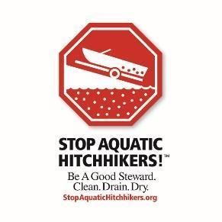


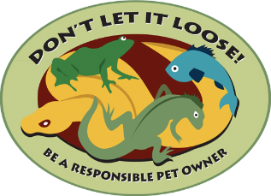
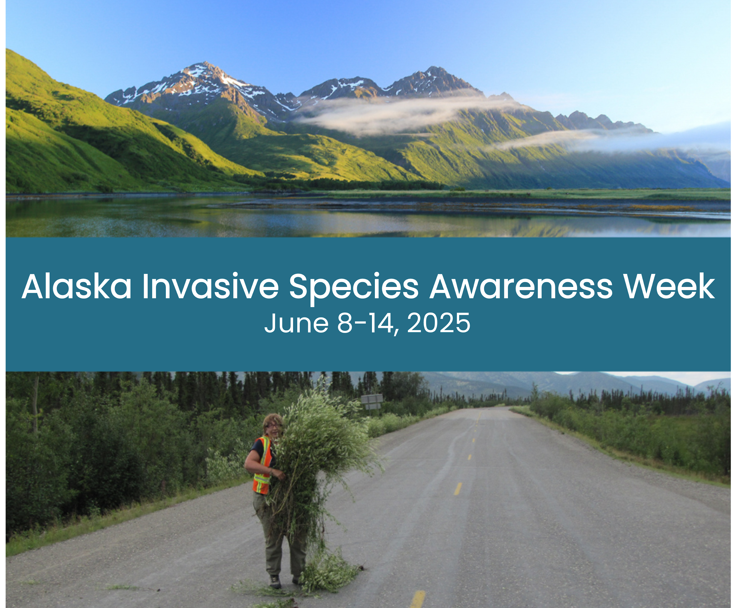
2025 AKISP Awareness Week Announcement.

Photo credits: US Fish and Wildlife Service (top), Michelle Michaud (bottom).

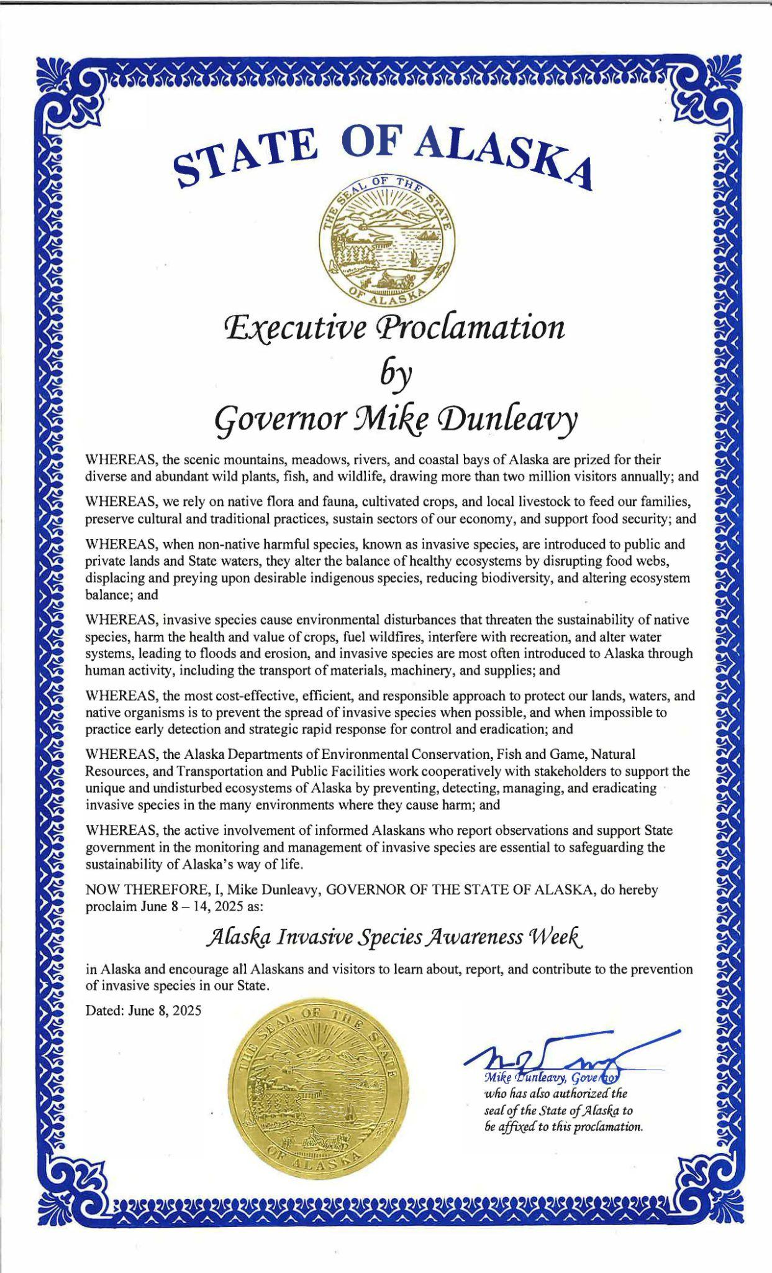
2025 Alaska Invasive Species Week Executive Proclamation, signed by the Governor.
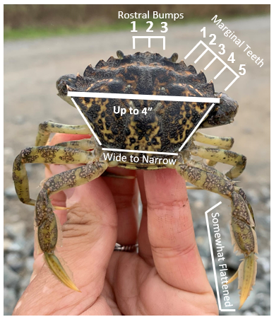
Invasive green crab - Key caparace characteristics of the European green crab.

Photo credit:Washington Dept. of Fish and Wildlife
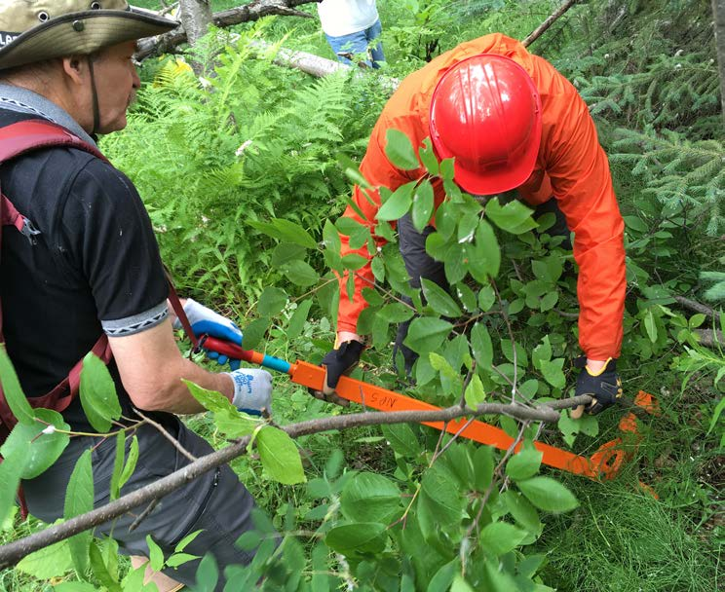
Invasive chokecherry being removed with a weed wrench.
Photo credit: Laurie Thorpe/Bureau of Land Management.
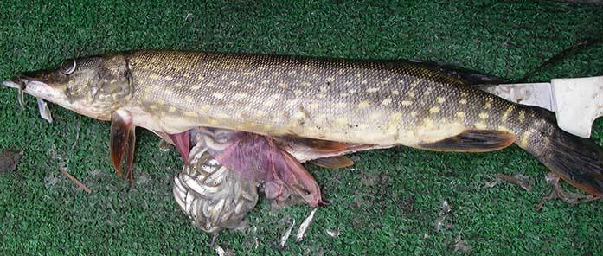
Invasive Northern Pike with a bellyful of juvenile salmonids.
Photo credit: Alaska Department of Fish and Game.

###

