Social Media Content from AKISP

The following social media content is available for sharing and posting on partner Facebook pages. Posts can be adapted as needed to better fit partner social media presence or to work for other social media platforms. There are accompanying images under each post. Hashtags to use during this week include #AKISAW and #InvasiveSpecies. For more information, contact the AKISP Outreach & Education Committee.

Did you know that Alaska Invasive Species Awareness Week is June 8-14? AKISAW is an annual event to raise awareness about invasive species and the impacts they have on Alaska’s environment and economy. You can tune into a local event (more info to come) or create your own using the AKISP outreach toolkit. Send AKISP a message if you’d like to learn more. #AKISAW #InvasiveSpecies

Photo credit: USFWS (top), Michelle Michaud (bottom)

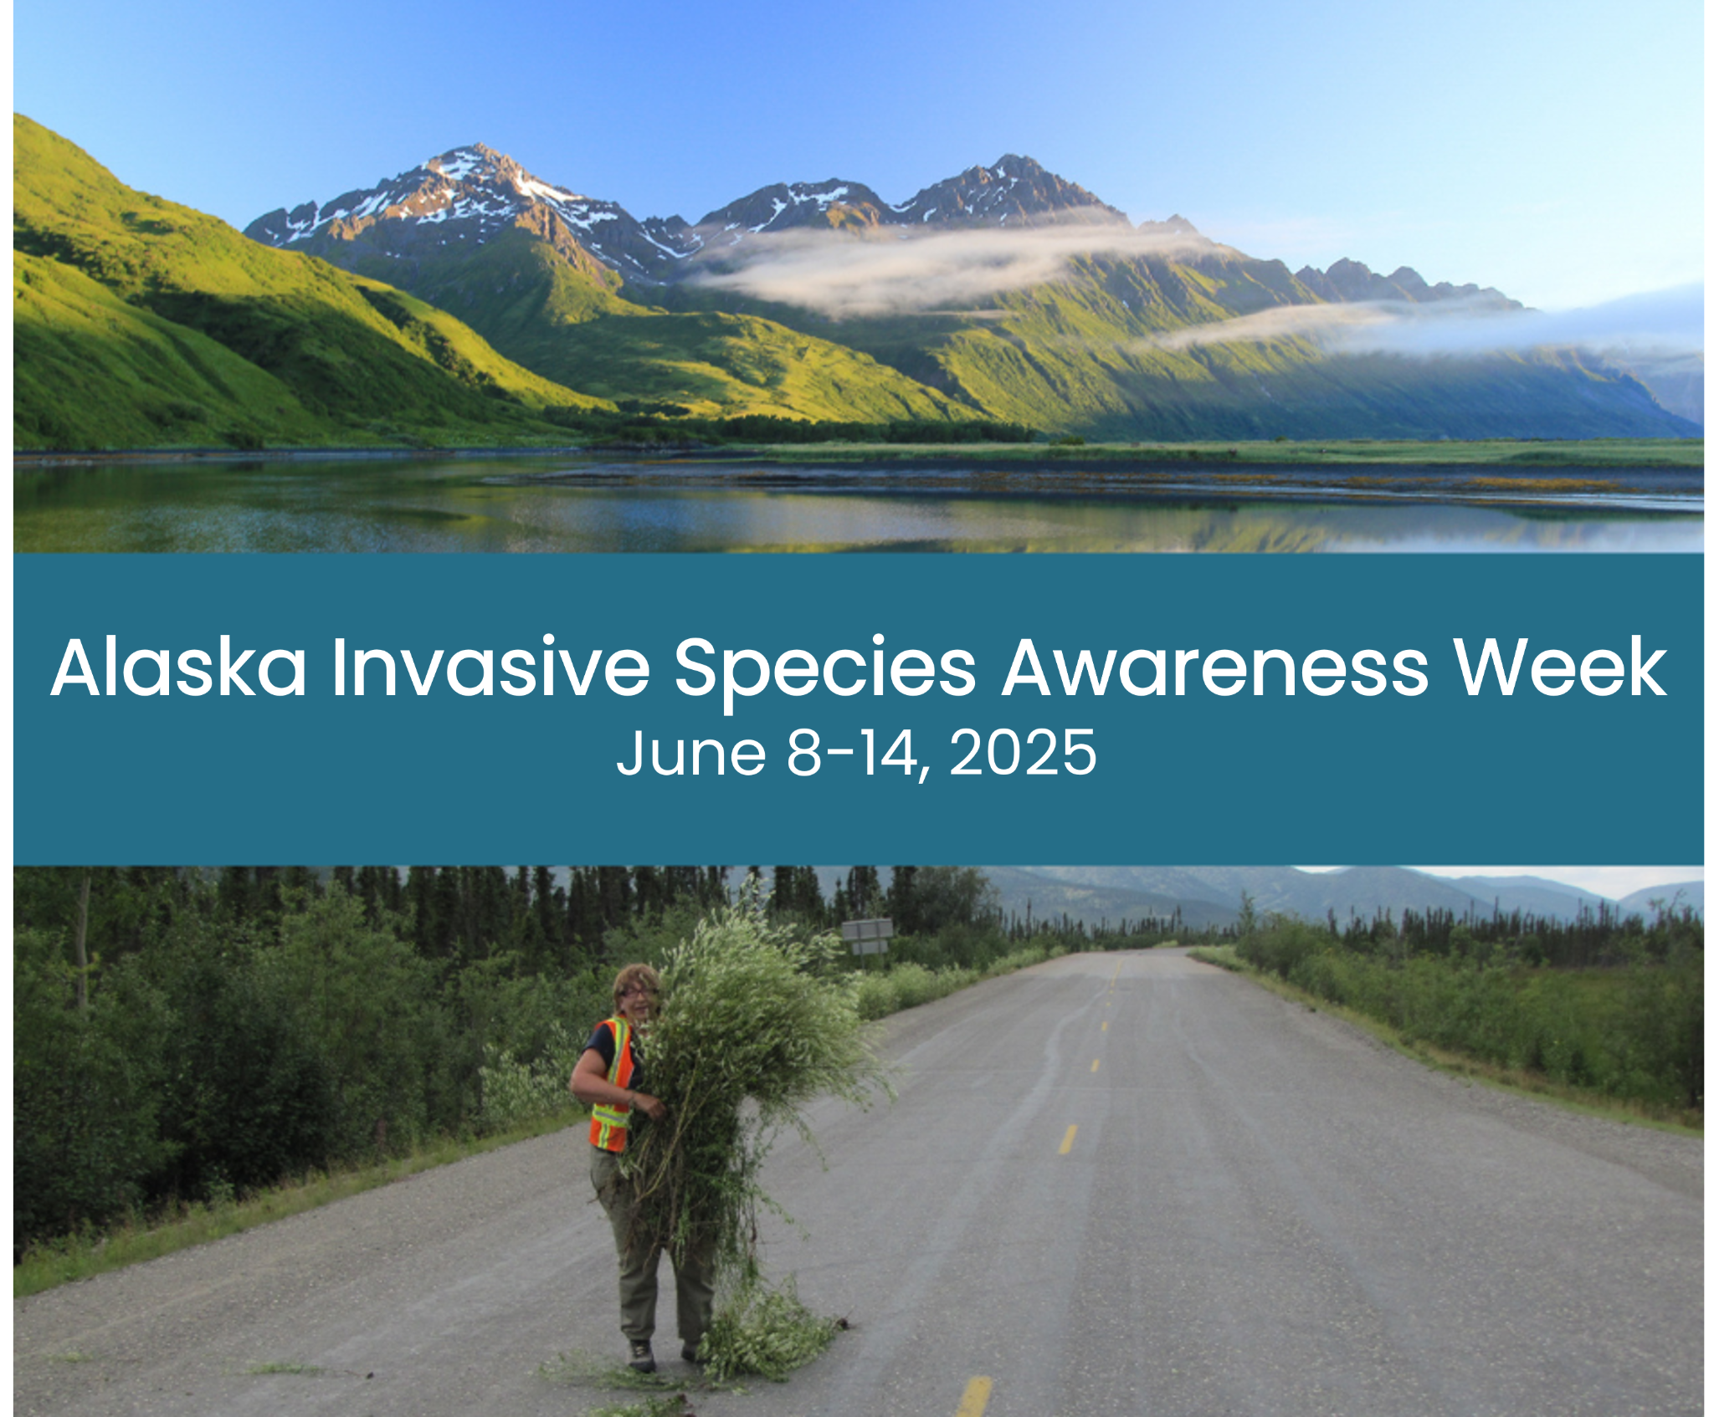

We’re celebrating because AK Invasive Species Awareness Week (AKISAW) is just around the corner! 🥳 Check out the Executive Proclamation from the Governor for why this week matters. #AKISAW #InvasiveSpecies
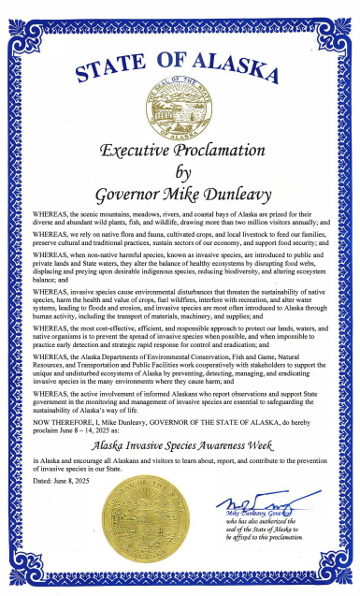

Share the news because it is Alaska Invasive Species Awareness Week (AKISAW)! From June 8-14, you can participate in a variety of events, from Facebook Lives to weed pulls. We’ve tried to capture a few of them in the following list and will continue to share partner events on this page. #AKISAW #InvasiveSpecies
Image of events and activities (will be compiled week prior to maintain relevancy)

Preventing the spread of invasive species is important because they can:
- Ruin our beautiful environment
- Endanger our native species
- Hurt our economy
- Damage infrastructure
- Risk human health
Learn more during this AK Invasive Species Awareness Week and participate in a local event. #AKISAW #InvasiveSpecies

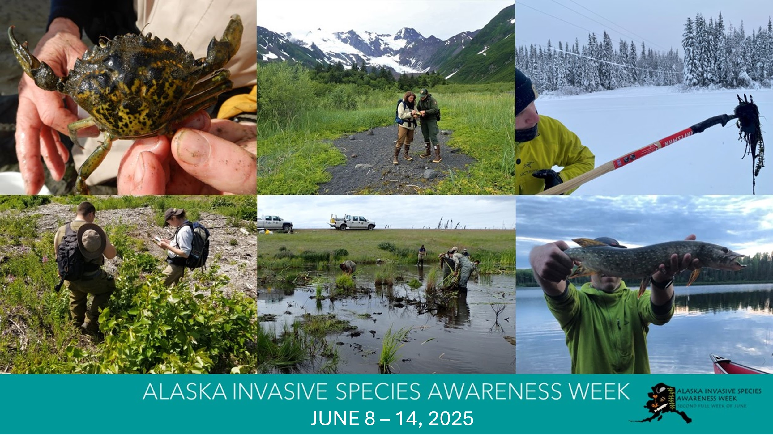

One way you can prevent the spread of aquatic invasive species is by using the best practice: Clean, Drain, Dry. Everywhere. Everytime. Wherever you go, prevent moving things between lakes by following these three simple steps to stop aquatic hitchhikers and be part of the solution. #AKISAW #InvasiveSpecies

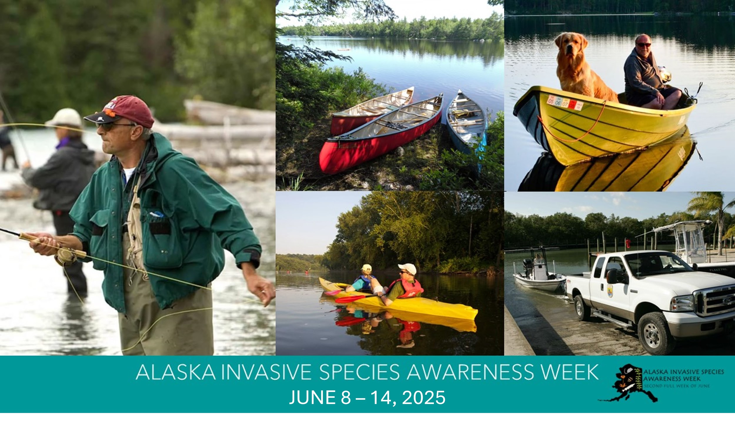

Warmer weather means it’s planting season, but when choosing what to grow, don’t plant a problem. Instead, show our native plants some love. Order from reputable nurseries and avoid planting flowers, trees, or shrubs known to be invasive. #AKISAW #InvasiveSpecies
https://www.uaf.edu/ces/publications/database/gardening/dont-plant-problem.php
Photo credit: Katrina Liebich/USFWS
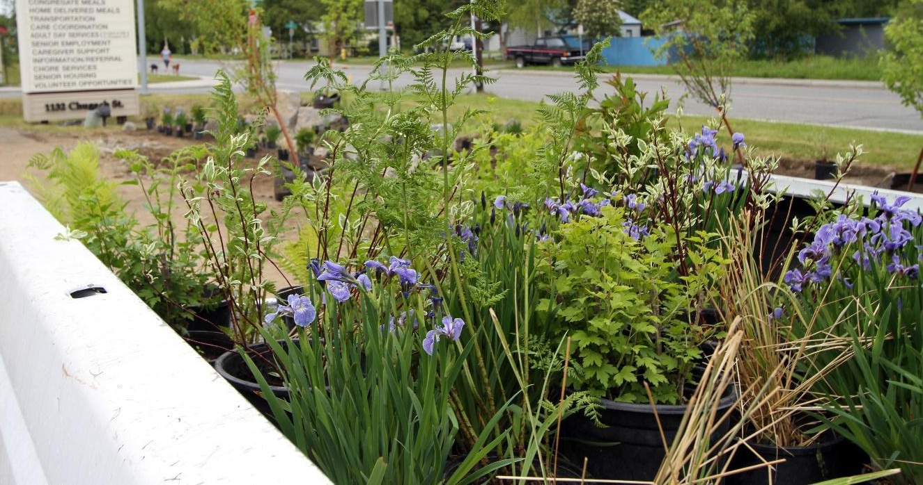

After AK Invasive Species Awareness Week, the work to prevent the spread of invasive species goes on! One way to do your part is cleaning your gear (boots, clothes, backpacks, etc) between outdoor adventures. This can be as easy as stopping at a boot brush station before/after hitting the trail! #AKISAW #InvasiveSpecies
Photo credit: USFWS; Maura Schumacher/Kenai Watershed Forum

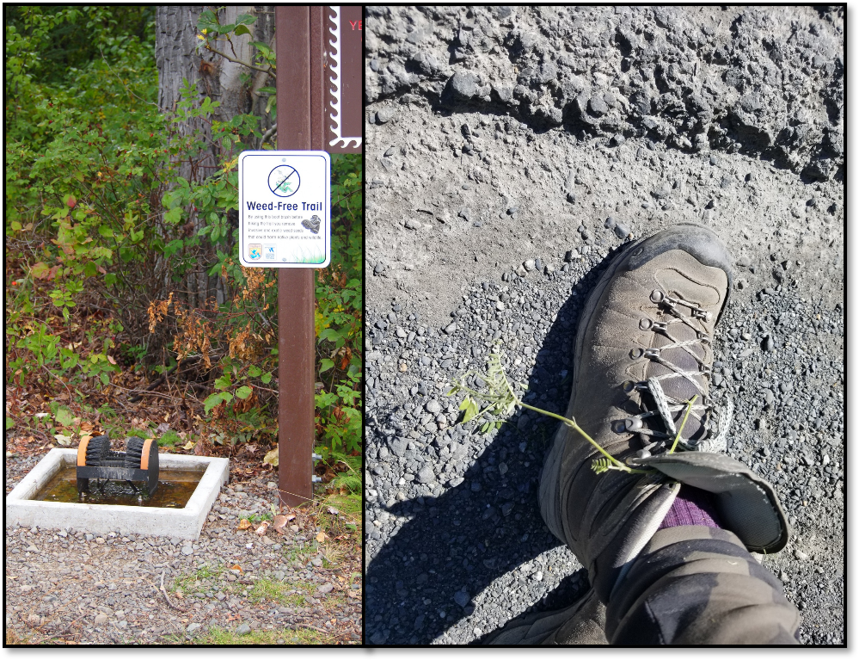

Invasive species impact all Alaskans. Hands (or thumbs) up if you’re a gardener! You can be part of the solution and help prevent invasive species by planting native flowers, trees, and shrubs. #AKISAW #InvasiveSpecies
Need inspiration? Check out these resources.
USFWS “Alaskans: plant this, not that”: https://www.fws.gov/story/alaskans-plant-not
UAF Cooperative Extension Service “Don’t Plant a Problem”: https://cespubs.uaf.edu/publications/?cat=7
Pollinator Partnership "Alaska Native Plant Options": https://www.pollinator.org/pollinator.org/assets/generalFiles/pollinator-garden-cards_Alaska_v2.pdf
Photo credit: USFWS. Collage of native Alaska plants (clockwise from the top left: salmonberry, woolly geranium, yellow locoweed, bluebells).
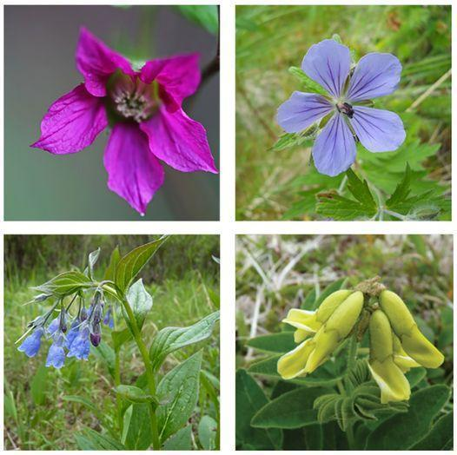

Zebra and quagga mussels have cost more than other invasive species, costing an estimated $6 billion in prevention and control efforts since their arrival in North America in 1988. While they have yet to be found in Alaska, members of AKISP are remaining vigilant to prevent them from entering the state via fouled motorboats, kayaks, canoes, rafts and other watercrafts. Learn more about Alaska Watercraft Inspection and Decontamination Station at the link below. https://www.fws.gov/project/watercraft-inspection-station-alaska-canada-border
#AKISAW #InvasiveSpecies
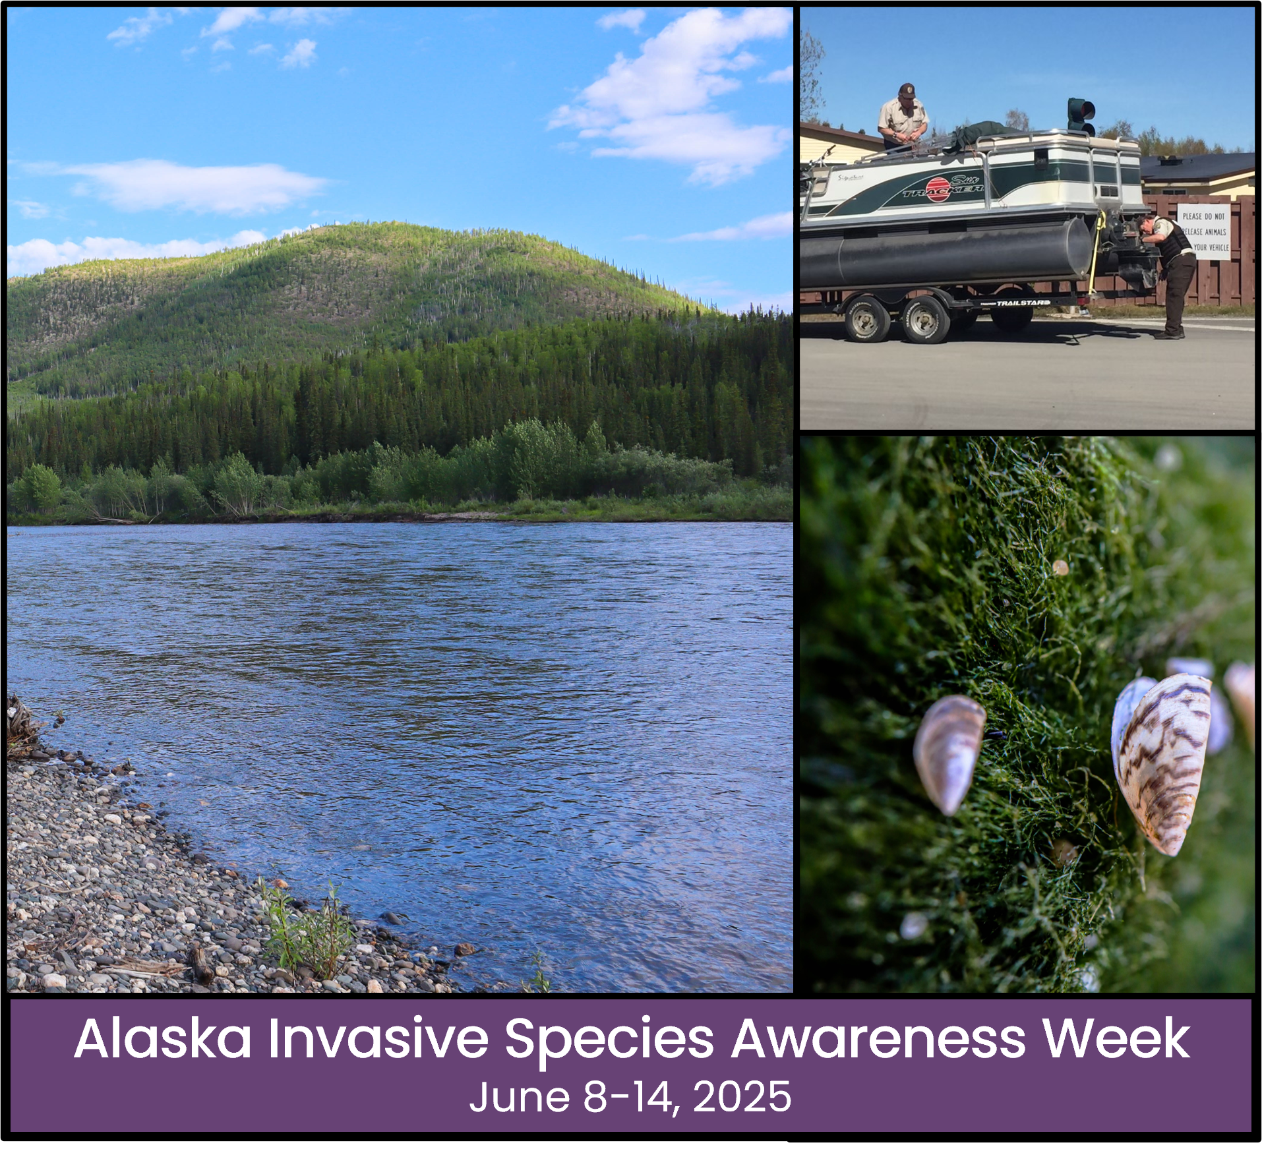

This week is Alaska Invasive Species Awareness Week (#AKISAW)! (Pronounced A-K-ee-saw if you want to be in the know 😉) This statewide event raises awareness about invasive species, the threats that they pose, and what can be done to prevent their spread. Interested in learning more and getting involved? Check out https://alaskainvasives.org/ 