Alaska Invasive Species Awareness Week (AKISAW)
Alaska Invasive Species Partnership (AKISP) Outreach and Education Talking Points

Purpose- to provide guidance on topics/points to make during AK-ISAW, enabling all partners to provide coordinated messaging throughout the week and beyond

Audience- AKISP partners planning on creating or partaking in outreach during AK-ISAW
--------------------------------------------------------------------------------------------------------------------------------------
The Alaska Invasive Species Awareness Week (AKISAW) has been adopted by AKISP and will take place during the second full week of June. This document will guide AKISP partners who wish to create outreach content or engage with local stakeholders, media outlets, and other community members during AKISAW. AKISP is encouraging partners to use their own social media and media outlets to spread the word about invasive species during this week. Messaging and content will be developed by the AKISP Outreach and Education Committee for distribution, but the creation of targeted, localized messaging by AKISP partners is also encouraged.

Materials provided by AKISP:
- Press release
- Radio PSAs (Clean Drain Dry and Play Clean Go)
- List of events and activities- AKISP website, Facebook and daily emails
- Social media content - create your own social media posts with our AK-ISAW Social Media Options document or share posts via the AKISP Facebook Page
- Daily emails - general reminders about AKISAW
- Printable species flyers
- AKISAW Logo

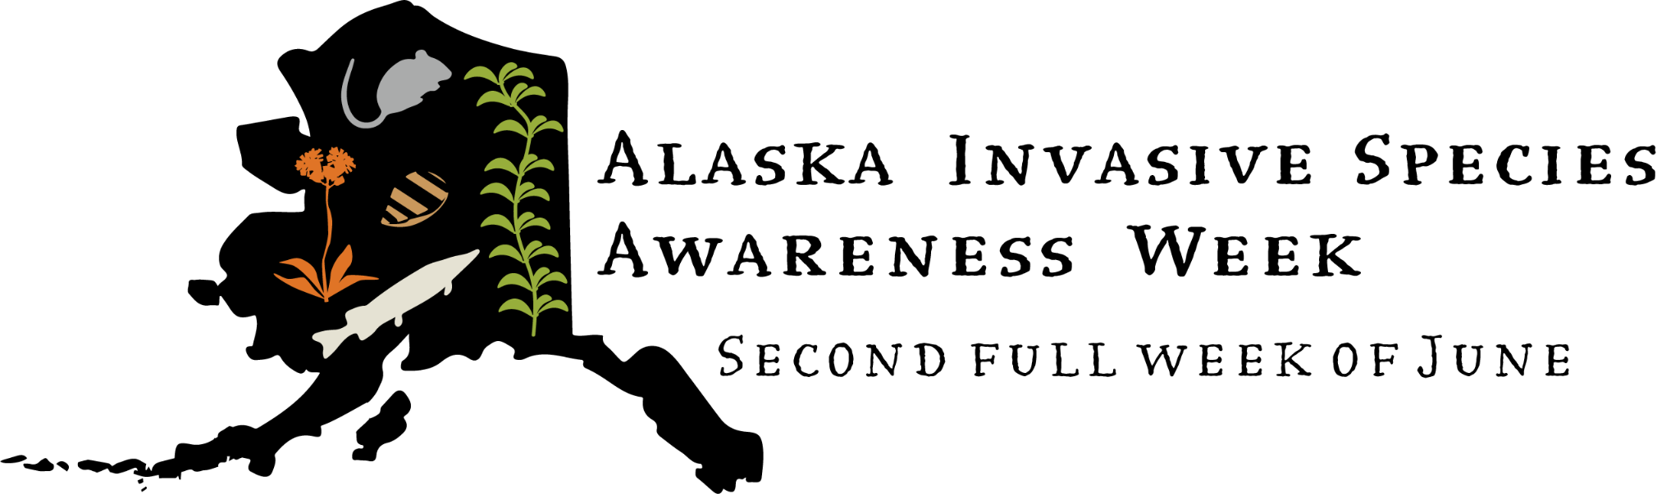

Ideas for outreach methods/venues (includes but is not limited to):
- Article/blog post
- Social media (Facebook, Instagram, Twitter, etc.)
- In-person event
- Online event
- Radio interview

Talking points

2025 AKISAW
- AKISAW is an annual event to raise awareness about invasive species and the threats they pose to the Alaskan environment and economy.
- AKISAW has been adopted by AKISP to take place annually during the second full week of June (June 8-14, 2025)
- The Governor signed an Executive Proclamation to support this awareness week
- AKISP is a group of organizations, agencies, and concerned citizens seeking to prevent invasive species from causing harm to Alaska environments, economies, and traditional ways of life.
- The purpose of this week of awareness is to engage members of the public in invasive species education and on-the-ground volunteer events.
- Anyone can participate in preventing the spread of invasive species across Alaska. Engagement from a wide variety of members of the public is necessary to prevent further negative impacts of invasive species.
- Invasive species management is incredibly important to Alaska’s economy, infrastructure, and environment. Preventing the spread of invasive species is an important means of protecting Alaska’s expansive landscapes and vital economic industries, such as sport and commercial fisheries, and eco-tourism.

Negative consequences of invasive species in Alaska
Invasive species are one of the greatest threats to biodiversity worldwide. While Alaska is still ahead of the “invasion curve” for many species, the detrimental impacts of invasive species present can be observed across the state. We must continue to act to prevent arrival or establishment of new species, mitigate negative consequences, and avoid spreading invasive species present.

Invasive species:
- Outcompete, endanger, and/or cause the extinction of native species, including subsistence species
- Reduce or eliminate profitable recreational and commercial fisheries for native species
- Degrade ecosystems
- Create inhospitable habitats for native species
- Reduce diversity and/or productivity of native species
- Make lakes and rivers unusable by boaters, anglers, and swimmers
- Damage boats and fishing gear
- Clog water pipes and increase the costs of operating drinking water facilities, power plants, and aquaculture facilities
- Harm human health
- Reduce property values of homes and businesses
- Compromise safe floatplane operation by blocking taxiways, fouling rudders, or becoming entwined in wires or cables
- Cost millions of dollars in control measures and economic losses

How invasive species spread in Alaska
Because of Alaska’s unique geography and variety of transportation opportunities, there are a wide variety of ways for invasive species to spread to remote and ecologically important areas of the state. These include:
- Transportation: boats, ships, floatplanes, etc.
- Highway, construction, and revegetation projects
- Intentional release of species outside their native range/illegal stocking
- Recreational equipment: hiking equipment, bikes, boots, backpacks, etc.
- Sportfishing equipment: clothing, waders, boots, tackle, nets, etc.
- Ballast water
- Bait release
- Live food/seafood packing industry
- Hull fouling
- Escaped ornamental plants, nurseries’ sales, and disposals
- Tsunami marine debris and other disaster debris
- Climate change
- Agriculture/Farming equipment
- Commercial shipping
- Roadway brushing, mowing, and snow plowing

Campaigns to Promote
- Stop Aquatic Hitchhikers/Clean Drain Dry
  - Audience: boaters, anglers, paddlers, commercial fishermen, etc.
  - Clean boats, trailers, and gear by removing weeds, mud, and anything hitchhiking before you leave the boat launch.
  - Drain water from boats by pulling plugs and all draining devices, emptying bilges and live wells, and disposing of unwanted bait in trash receptacles. .
  - Dry everything – if you have been in waters where aquatic invasive species are known to occur or observed, wait at least five days, completely dry, or decontaminate with hot (120°F) high pressure water before launching into a new water body
- PlayCleanGo
  - Audience: hikers, mountain bikers, OHV-ers, horse owners, anglers, gardeners, boaters, paddlers, hunters, etc.
  - Remove plants, animals, and mud from boots, gear, pets, and vehicles.
  - Clean your gear before entering and leaving recreation sites.
  - Stay on designated roads and trails.
  - Use certified or local firewood and hay.
- Don’t Move a Mussel
  - Audience: boaters, anglers, aquarium owners, paddlers, commercial fishermen, etc.
  - Clean, Drain, and Dry, Everywhere. Every Time boats and other aquatic recreational gear when moving from one water body to another.
  - NEVER dump aquarium contents into wild waterways or public water drainage systems.
- Don’t Plant a Problem/Pest
  - Audience: gardeners, garden clubs, farmers, etc.
  - Don’t plant flowers, trees, or shrubs that are known to be invasive.
  - Watch for species that have the potential to become troublesome and help share information.
  - Order from reputable nurseries that are not likely to mislabel plants or sell weedy seed mixes.
  - Share only weed-free plants, soil, shrubs, etc with fellow gardeners.
  - When you purchase new plants, watch to make sure that you don’t introduce weeds hitchhiking in pots or root balls.
  - Make sure that you don’t introduce problems by planting non-native wildflower seed mixes, which can contain invasive species or weed seeds.
- Don’t Let it Loose
  - Audience: pet owners, aquarium owners, pet stores, students, veterinary clinics, etc.
  - Never release your pets into the wild
  - Never dump your aquarium pets, plants, or water into Alaska waters or storm drains.
  - Contact your local pet stores, animal shelters, veterinarians and online groups to re-home your unwanted pet(s).
  - Any pets that cannot be re-homed should be humanely euthanized.
- Don’t Move Firewood
  - Audience: tent campers, RV campers, etc.
  - Buy (or collected if permitted) firewood where you plan to burn it.
  - Leave firewood at home unless burning locally (less than 50 miles).
  - Only buy what you need and burn it all before leaving.
  - Leave firewood where you bought/collected it. Don’t move it to your next destination.
- Don’t Dump Your Bait
  - Audience: Anglers, boaters, sport fishermen, etc.
  - Dispose of unwanted bait in the trash or retain unused bait for your next fishing trip
  - Only return catch-and-release fish back to the waters where they were caught. Transporting live fish requires a permit unless legally held for regulated purposes.

HOW TO TAKE ACTION
- Report
  - Telephone: Report invasive species sightings to the Alaska Invasive Species Hotline at 1-877-INVASIV
  - Web: Report Invasive Species online by using the Alaska Department of Fish and Game Invasive Species Reporter or University of Alaska Citizens Monitoring Portal
  - Smartphone App: Use the Alaska Invasives ID App to search for and identify invasive species and report infestations
- Stop Aquatic Hitchhikers by cleaning, draining, and drying boats and other equipment when moving from one water body to another
- PlayCleanGo by cleaning all equipment before and after hiking, biking, hunting, horseback riding, etc.

For more information on how to spread the word during Alaska-ISAW, please contact one of the AKISP Outreach and Education Committee officers:
Ashley Lutto, ashley_lutto@fws.gov (Statewide)
Gooseberry Peter, gpeter3@alaska.edu (Fairbanks)
Jen Chauvet, jen@homerswcd.org (Southern Kenai Peninsula)
Summer Nay, summer.nay@salchadeltaswcd.org (Delta Junction)

Visit Alaskainvasives.org to learn more about AKISP and reporting tools.

